英语学科高考题型重组练六
限时40分钟
Ⅰ. 阅读理解
A
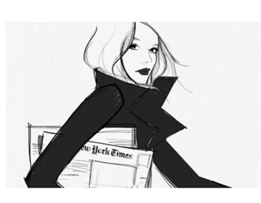
For most of her life, Suanne Laqueur’s passion for storytelling was shown on the dance floor.
Although Laqueur began writing at a young age, dancing always took center stage. She majored in dance and theater at Alfred University and taught at her mother’s dance studio in Croton-on-Hudson, New York, for years. But when her mother was ready to retire and an opportunity opened for Laqueur to take over the studio, she realized she had no interest in taking on the business side of her art: “Owning a studio is a lot of work—financially, logistically. I love the teaching, the choreographing(编舞), the staging, but I didn’t want to own it. ”
Yet Laqueur’s disinterest in running the studio changed when she became a self-published author. In the fall of 2013, she decided to pursue self-publishing as a way of sharing her first completed novel with friends and family. During the process, she realized that following her true passion—telling stories through writing—made the business of the art worthwhile, and owning that business meant she could direct her writing career however she chose.
Starting with her second self-published novel, she began investing more time in marketing and building her audience. Her investment paid off. Since 2014, Laqueur, now 49, has self-published six novels, which collectively have hundreds of ratings and reviews on Goodreads. Her 2016 novel An Exaltation of Larks stole the show at the 25th Annual Writer’s Digest Self-Published Book Awards, topping more than 2, 300 entries to win the grand prize.
“You have to write the most truthful story to you, and I think self-publishing allows that freedom, ” she says. “If you work with traditional publishing, it’s more about what’s marketable, There are trade-offs, which everyone will tell you, but by self-publishing I have control of the book, I have control of the story, and I’m cool with that. ”
1. From Paragraph 2, we can learn that Laqueur _________.
A. wanted to own a publishing house
B. didn’t like teaching dancing in fact
C. was a part-time writer when she was young
D. was interested in running her mother’s studio
2. What made Laqueur change her attitude to business?
A. Her mother’s persuasion.
B. Self-publishing her novels.
C. The desire to make money.
D. Her own passion toward art.
3. Which of the following can best replace the phrase “stole the show” in Paragraph 4?
A. became a failure.
B. was shown to people.
C. got all the attention.
D. was accidentally stolen.
4. What can be inferred from what Laqueur’s said?
A. She enjoys the way of self-publishing.
B. She will never use traditional publishing.
C. Traditional publishing only focuses on the market.
D. Self-publishing will replace traditional publishing.
B
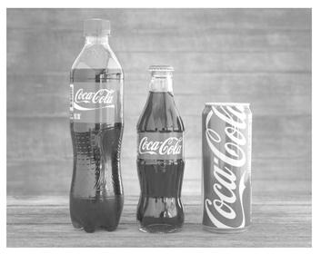
Coca-Cola, which reportedly produced more than 3 million tons of plastic packaging in 2017, announced Thursday it wants to “help fix the world’s plastic waste problem one community (社区) at a time. ”
The soda giant is doing so by providing $ 5. 4 million for recycling programs in cities like Atlanta, Boston, Denver and Houston. In these cities, partners, like The Green Blue Institute and The Recycling Partnership, which receive the money, will work together to improve recycling rates.
“We focus on areas where we have the ability to make the biggest influence on communities through the funding and expert skills of Coca-Cola employees, ” Carlos Pagoagoa, Coca-Cola’s group director of community partnerships, said in a statement. “In each city, local partners will work together to identify barriers to recycling on a local level and test a range of solutions, ” he added. “We hope the learning from these ‘model markets’ can offer solutions to other cities facing similar challenges. ”
As part of the effort, The Recycling Partnership and the city of Atlanta, where the cola company’s headquarters are based, will send street teams out to open recycling carts and leave citizens cards informing them what they can and can’t recycle, and let them know how their efforts work.
“Two of the most urgent problems with recycling in the U. S. today are lack of access, followed by pollution in recycling, ” Keefe Harrison, CEO of The Recycling Partnership, said in a statement. “We know from the success of Atlanta in 2017 that the citizens want to recycle, and that communicating with them in the street works. ”
Last year, Coca-Cola announced its task to collect and reuse a bottle or can for each one it sells, and increase the amount of its products out of recycled materials to 50% by 2030. The brand also aims to make all its packaging fully recyclable by 2025.
5. What does Coca-Cola company intend to do in the program?
A. Produce less packaging.
B. Help deal with plastic waste.
C. Pick up waste in communities.
D. Build a plant to recycle plastic waste.
6. What’s Paragraph 2 mainly about?
A. How Coca-Cola conducts its program.
B. What organizations participate in the program.
C. How Coca-Cola chooses cities for the program.
D. What the local people do in Coca-Cola’s program.
7. What do street teams do to help?
A. Sort out various waste in the city.
B. Look into the cause of pollution.
C. Instruct local people what to recycle.
D. Hand cards to the locals in person.
8. What does Keefe Harrison think of the program?
A. Promising. B. Difficult.
C. Pioneering. D. Costly.
Ⅱ. 完形填空
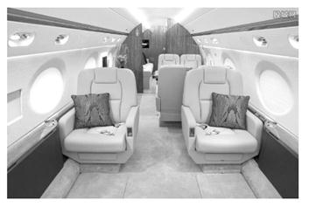
On Dec. 6, Kelsey Zwick boarded Flight 588 from Orlando to Philly with Lucy, one of her 11-month-old twin daughters. Lucy was born 11 weeks prematurely(早产)and 1 from severe lung disease as a result of a complication(并发症)of that. The brave baby girl was on oxygen 2 until recently. Today, Lucy needs oxygen at night and while 3 — one small good deed reminded Zwick how 4 she and her husband, Yuri, truly are.
“To the 5 in 2D. I don’t know you, but I imagine you saw us 6 . I was pushing a stroller (婴儿车), had a diaper(尿布) bag on my arm and also 7 an oxygen machine for my daughter, ” Zwick wrote on her Facebook post. “We 8 the plane, sat down in our window seat and made 9 to those around us about having to sit by my yelling-but-happy baby. The flight attendant came over and told me a gentleman was waiting to 10 seats, ” she wrote. “You were giving up your comfortable, first-class seat to us. Not able to 11 tears, I cried my way up the 12 while my daughter Lucy 13 ! She felt it in her bones too. . . real, pure, goodness. I smiled and thanked you as we switched but didn’t get to 14 you properly, ” the mom continued.
“So. . . thank you. Not just for the seat itself but for 15 . For seeing us and realizing that maybe things are not 16 easy. For deciding you wanted to show a random act of 17 to us. I can’t wait to tell Lucy someday. In the meantime. . . we will pay it 18 . ”
Zwick’s story touched the hearts of many, giving rise to 19 comments on the post that has since been 20 over 164, 000 times.
1. A. recovers B. suffers C. results D. benefits
2. A. test B. health C. survival D. support
3. A. playing B. flying C. sleeping D. growing
4. A. astonished B. amused C. blessed D. anxious
5. A. man B. attendant C. assistant D. guide
6. A. somewhere B. anywhere C. nowhere D. everywhere
7. A. filling B. pumping C. following D. dragging
8. A. booked B. reserved C. pre-boarded D. quit
9. A. complaints B. comments C. offers D. jokes
10. A. choose B. switch C. accept D. occupy
11. A. burst into B. give back C. hold back D. break into
12. A. passage B. airport C. flight D. pilot
13. A. shouted B. crawled C. talked D. laughed
14. A. meet B. thank C. recognize D. accept
15. A. noticing B. donating C. reminding D. forgiving
16. A. just B. right C. always D. ever
17. A. forgiveness B. advantage C. kindness D. donation
18. A. forward B. downward C. backward D. toward
19. A. passive B. supportive C. possible D. negative
20. A. made B. chosen C. researched D. shared
Ⅲ. 书面表达
假定你是李华, 你的朋友Peter想了解你校于五月举办的中国传统文化艺术节。请你给Peter写封回信, 内容包括:
1. 举办艺术节的目的;
2. 介绍你最喜欢的一个艺术节活动;
3. 邀请Peter参加并告之艺术节活动的时间。
注意:
1. 词数 100 左右;
2. 可以适当增加细节, 以使行文连贯。
Dear Peter,
____________________________________________________________________
____________________________________________________________________
Yours,
Li Hua

